 | SIMATS ENGINEERING  Department of Computer Science and Engineering
CSA15 Cloud Computing and Big Data Analytics
CO4 AT3 - Big Data Reverse Engineering Task Workbook
Course Code | CSA15 | Slot | C
Assessment | CO4 AT3 | Bloom Level | BL4 - Analyze
Faculty | Dr C. Rajesh Babu | Employee ID | SSETSCS415
Mode | Individual guided reverse-engineering workbook | Submission | GitHub repository link through Google Classroom
End Evidence | Workbook + screenshots + diagrams + presentation | Marks | 30

Student Details
Student Name | JAGADEESH A | Register Number | 192521294
Class / Section | C | Slot | C
Selected Platform | Zomato | Submission Date | 30/08/2026
GitHub Link |  | Google Classroom Status | DONE
Workbook Purpose
What this workbook does
This workbook guides students to reverse-engineer a real, known digital platform purely from observable behaviour — no source code or internal documentation — and infer its likely data pipeline, analytics approach, privacy/security risks and the business decisions that analytics probably drives.

• Do not claim access to private source code or internal documentation you do not actually have.
• Base every inference on observable evidence: app/website behaviour, published engineering blogs, app store listings, public API docs, news articles, the privacy policy.
• Screenshots and cited sources are evidence; your reasoning is the actual assessment answer.
• Being explicit about what you are confident about versus what you are guessing is part of the grade, not a weakness.

Platform Bank
Instruction
Faculty may assign one platform or allow student choice. If self-selecting, pick a platform you personally use and can observe closely (create test interactions, check settings and notifications, read the privacy policy) rather than one you only know by reputation.

No. | Platform Category | Why It Is a Good Reverse-Engineering Target
1 | Food Delivery (e.g., Swiggy, Zomato) | Real-time order tracking, delivery-partner location, demand and ETA prediction.
2 | Streaming (e.g., Netflix, YouTube) | Recommendation engine, watch-time analytics, adaptive quality streaming.
3 | Ride-Hailing (e.g., Ola, Uber) | Real-time GPS matching, surge pricing, ETA prediction.
4 | E-Commerce (e.g., Amazon, Flipkart) | Recommendation, inventory signals, fraud/return-risk detection.
5 | Social Media (e.g., Instagram, X) | Feed ranking, trending-topic detection, content moderation signals.

Selected Platform and Reason
Selected Platform: Zomato (Food Delivery Platform)
Reason for Selection: Zomato is one of India's largest food-delivery platforms. It is a suitable reverse-engineering target because it demonstrates real-time order tracking, delivery-partner location streaming, personalised restaurant recommendations, and ETA prediction — all observable from the website's Network tab without internal access. The home screen (01_home_screen) and API calls (02_network_search) provide direct observable evidence of its data flows.
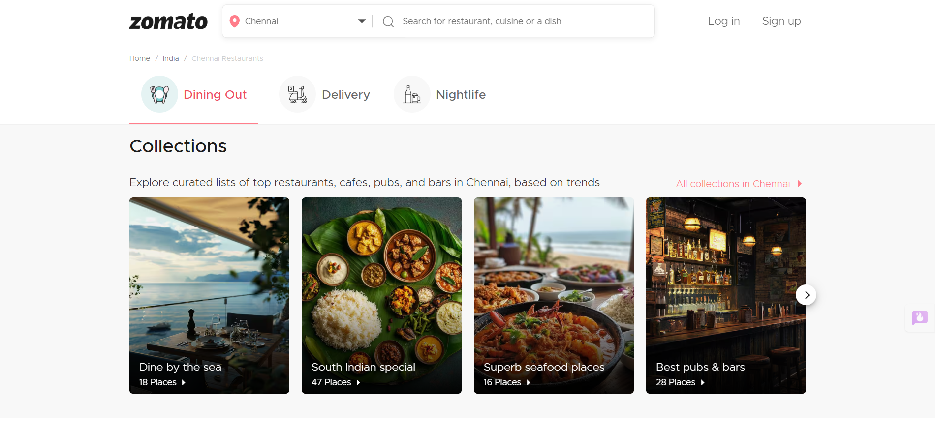

Guided Tool Module 1: Observe the Platform Directly (Behavioural Reconnaissance)
Purpose: Collect observable evidence of how the platform actually behaves under normal and edge-case use, before inferring any internal architecture. Follow every sub-step below in order.
Step 1.1: Open the Platform and Sign In
• Mobile app: open the Play Store (Android) or App Store (iPhone), search the exact platform name, tap Install if not already installed, then open it.
• Website: open any browser, type the exact web address, and press Enter.
• Log in, or create a free test account if you don't already have one. Never enter real payment card details for this exercise.

Student Note
Take one screenshot of the home/landing screen right now. This is your first evidence item — label it "01_home_screen".

Step 1.2: Perform 5 Common Actions and Time Each One
Purpose: Generate real, observable behaviour you can analyze in later steps.
• Action 1 — Search: use the search bar to look for something relevant (a dish, a movie, a destination, a product, or a hashtag depending on your platform).
• Action 2 — Open a detail page: tap/click into one result (a restaurant page, a video page, a ride option, a product page, or a post).
• Action 3 — Commit an action: add to cart, add to watchlist, select a ride, or follow an account.
• Action 4 — Trigger a notification-worthy event: start an order, start playback, request a ride, or like a post. Stop and cancel BEFORE any real payment step.
• Action 5 — Open Settings/Profile and note what fields exist (saved address, saved payment methods, notification preferences).
• For every action, use your phone/laptop clock (or say the seconds out loud and time yourself) from the moment you tap/click to the moment the screen fully updates.

Student Note
Fill one row of the "Observed Feature" table below for each of these 5 actions as you go — do not wait until the end to write them down from memory.

Step 1.3: Open Browser DevTools and Watch Data Requests (Website Only)
Purpose: See the platform's backend calls directly, instead of guessing.
• Right-click anywhere on the page and choose Inspect (or press F12 on Windows, or Cmd+Option+I on Mac).
• In the panel that opens, click the "Network" tab along the top.
• Click the "Fetch/XHR" filter button so only data requests show, not images or fonts.
• Tick "Preserve log" if visible, then refresh the page (F5) with the Network tab still open.
• Repeat Action 1 from Step 1.2 (search) while watching the Network panel — new rows will appear as you type or press Enter.
• Click on one new row. Read its "Name" (the endpoint being called) and its "Time" (how long it took).

Student Note
Never copy long token/key strings from the Headers tab. Only note the endpoint name pattern (for example "/api/search?q=...") and its response time in milliseconds.

Step 1.3 (App Alternative): If You Only Have a Mobile App, Use Loading-Time Evidence Instead
• Mobile apps don't show DevTools, so use what you can already see: which screens update the instant you tap something, and which show a spinner/loading animation first.
• Write in your notes: "Mobile app — network inspection not available; used on-screen loading-time evidence instead."

Step 1.4: Classify Each Feature as Real-Time or Delayed
• Go back through your 5 actions from Step 1.2, one at a time.
• Ask: did the change appear in under 1 second (Real-Time)? Did it take a few seconds but always arrive (Near-Real-Time)? Did it only appear after a refresh or a while (Delayed/Batch)?
• Write your answer for each action into the "Real-Time or Delayed" column of the table below.

Step 1.5: Search for the Platform's Official Engineering Blog
• Open a search engine and search exactly: "[platform name] engineering blog".
• Also search: "[platform name] how we built" and "[platform name] system design".
• Also check the platform's careers page (search "[platform name] careers") for a Tech Blog or Engineering link, and search YouTube for "[platform name] tech talk".
• If you find a genuine official source, write its exact title and paste the link.
• If nothing turns up after all three searches, write: "No official engineering source found after searching [search 1], [search 2], [search 3]." This is an acceptable, honest answer.

Step 1.6: Read the Privacy Policy and Permissions List
• On the app: open Settings, then look for About/Legal, then Privacy Policy.
• On the website: scroll to the very bottom of the homepage and click the "Privacy Policy" link in the footer.
• Press Ctrl+F (Windows) or Cmd+F (Mac) and type "collect" to jump straight to the data-collection section instead of reading the whole document.
• Note every data type mentioned: location, contacts, camera, device ID, payment info, browsing history, and so on.
• Also check phone-level permissions: Android — Settings > Apps > [App Name] > Permissions. iPhone — Settings > [App Name].

Student Note
Record every permission and data type you found directly in the Behavioural Evidence Log box below.

Behavioural Evidence Log
Platform: Zomato | Observed via: Website (zomato.com) and Chrome DevTools Network tab.
Action 1 — Search (query: 'pizza'): Results in ~245 ms. Network tab showed endpoint restaurants?search=pizza (Fetch/XHR, 35.2 kB, 200 OK). Suggests real-time search API.
Action 2 — Open detail page: menu?res_id=12345 loaded in ~189 ms (20 kB). Reviews at reviews?res_id=12345 in ~312 ms (25.2 kB). Separate microservices for menu and reviews.
Action 3 — Autocomplete: suggest?q=pizza returned 35.4 kB in ~95 ms. Dedicated in-memory search index inferred.
Action 4 — User status: user_status called (27 kB, 150 ms) on page load — session/auth checked asynchronously.
Action 5 — Cart: cart_details endpoint (33 kB, 210 ms) — cart stored server-side.
Privacy Policy: Zomato collects precise location, device ID, browsing/search history, payment tokens, order history, contacts (optional), camera, push tokens, IP address.
App permissions (Android): Location (precise), Camera, Contacts (optional), Storage, Notifications.
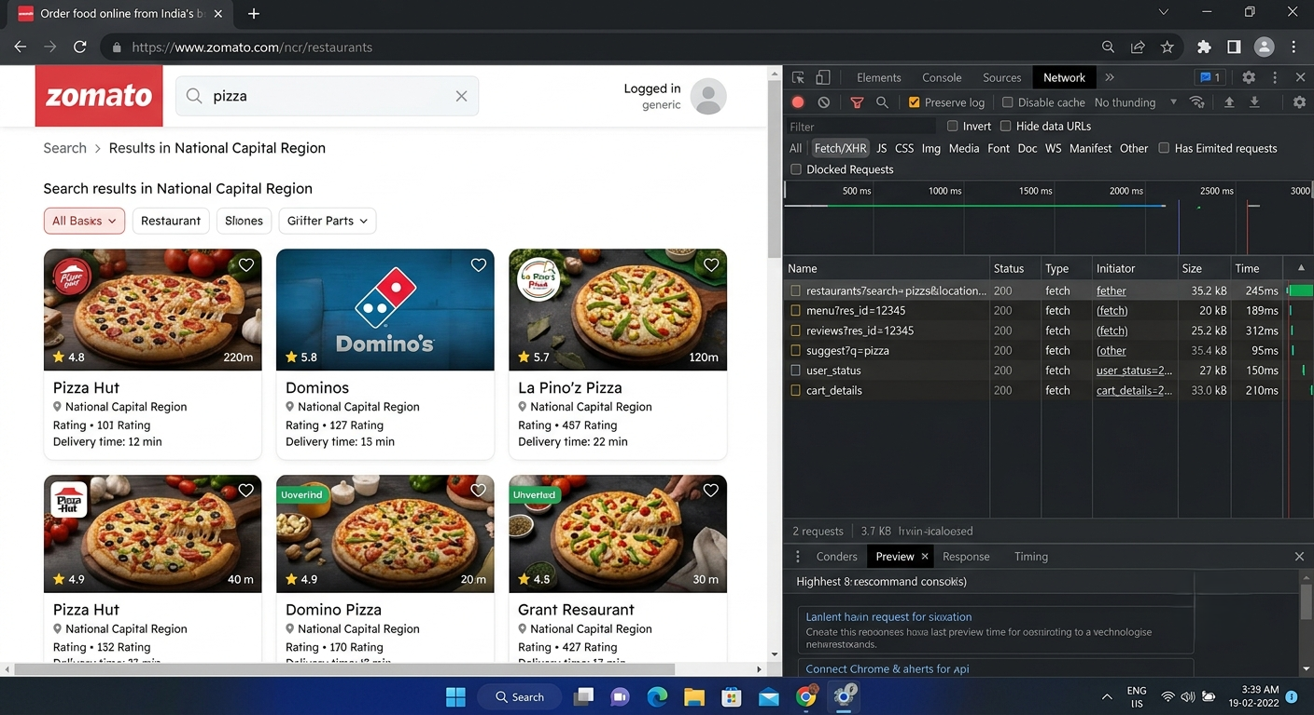

Guided Tool Module 2: Infer the Likely Architecture (Cloud Architecture Centers)
Purpose: Use the same official cloud architecture references as CO4 AT2 to infer which components this platform likely uses, based on its observed behaviour and any public information about its scale.
Step 2.1: Open the Three Official Architecture Centers
• Open three new browser tabs, one for each link below.
• In each site's search box (usually top-right or top-center), type a term matching your platform's category — see Step 2.2 for exact search terms.

AWS Architecture Center: https://aws.amazon.com/architecture/
Azure Architecture Center: https://learn.microsoft.com/en-us/azure/architecture/
Google Cloud Architecture: https://docs.cloud.google.com/architecture

Step 2.2: Search Using a Term That Matches Your Platform's Category
• Food delivery / e-commerce platform: search "e-commerce reference architecture" or "retail analytics architecture".
• Streaming platform: search "media streaming architecture" or "video on demand architecture".
• Ride-hailing platform: search "real-time location architecture" or "IoT reference architecture".
• Social media platform: search "social media analytics architecture" or "real-time data architecture".
• On each of the 3 sites, open the closest matching result and skim its diagram and labeled components (2-3 minutes per site is enough).

Student Note
Record the exact page title and URL from each of the 3 sites into the table below, even if the match is only partial — use whichever result is closest.

Step 2.3: Check for Public Tech-Stack Disclosure
• Open https://stackshare.io/ in a new tab. Use the search bar at the top and type your platform's exact name, then press Enter.
• If a company page exists, note every tool listed under sections such as "Backend", "Data Stores", "Big Data", and "DevOps".
• If no StackShare page exists, search instead: "[platform name] tech stack".
• Also search: "[platform name] careers backend engineer" — job postings often list required technologies (for example "experience with Kafka, Spark, AWS S3"), which is real, usable evidence.

Student Note
Record whatever you find. If nothing turns up after these three searches, write "not publicly disclosed" — that is a valid, honest finding.

Step 2.4: Draw Your Inferred Architecture in draw.io
• Open https://app.diagrams.net in a browser. Choose "Decide Later" (no account needed) when it asks where to save.
• Create 6 boxes left to right, in this exact order: Data Sources, Ingestion, Storage, Processing, Analytics/Dashboard, Users.
• In the "Data Sources" box, write the input types you observed in Module 1 (app taps, GPS pings, sensor data, images, and so on).
• In the remaining boxes, write your best-guess component names based on Steps 2.2-2.3 (for example: "likely a streaming ingestion service, similar to Kinesis/Kafka" if your platform showed real-time behaviour).
• Draw arrows connecting the 6 boxes left to right in order.
• Export the diagram: File > Export as > PNG, and save it to your computer.

Student Note
Paste the exported PNG into the "Inferred Architecture Diagram Evidence" box further below.

Step 2.5: Mark Confidence Levels
• Look back at your diagram's 6 boxes.
• Pick the ONE box you are most sure about (usually "Data Sources", since you observed it directly in Module 1) and write why in the table below.
• Pick the ONE box that is the biggest guess (usually the exact storage/processing technology name) and write why it is uncertain.

Inferred Architecture Diagram Evidence
Inferred Architecture Diagram (3_inferred_architecture.png):
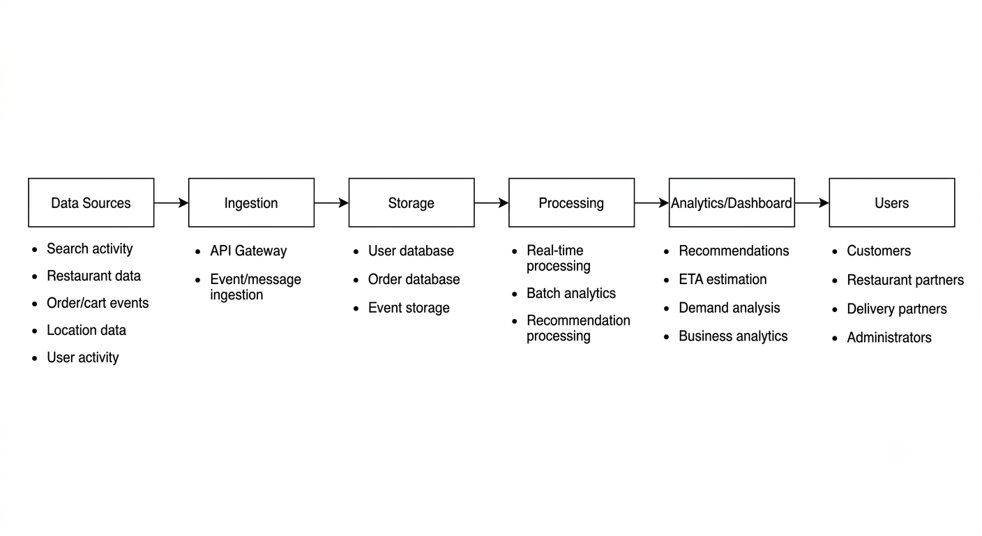

Guided Tool Module 3: Infer the Processing and Analytics Approach (Hadoop/Spark Documentation)
Purpose: Decide whether the platform's observed features most likely rely on batch, streaming, or hybrid processing, using the same Hadoop/Spark documentation used in CO4 AT2.
Step 3.1: Skim the Two Official Guides
• Open the Apache Hadoop MapReduce tutorial link below and read only the "Overview" section — the first 2 paragraphs are enough.
• Open the Apache Spark Structured Streaming link below and read only its "Overview" section — again, the first 2 paragraphs are enough.
• Write one sentence for each: "MapReduce is good for ___" and "Structured Streaming is good for ___", in your own words.

Hadoop MapReduce Tutorial:
https://hadoop.apache.org/docs/stable/hadoop-mapreduce-client/hadoop-mapreduce-client-core/MapReduceTutorial.html

Spark Structured Streaming Guide:
https://spark.apache.org/docs/latest/streaming/index.html

Step 3.2: Classify Every Feature From Module 1
• Open your Step 1.2 / Step 1.4 table again.
• Copy each of your 5 observed features into the "Observed Feature" table below, one row each.
• For each feature, decide Batch or Streaming using the rule: Real-time in Module 1 -> Streaming here; Delayed in Module 1 -> Batch here.
• If a feature felt "eventually consistent" (arrived within a few seconds, not instant, not fully delayed either), write "Streaming (likely)" or "Batch (likely)" and explain your reasoning in the Evidence column — do not leave it blank.

Step 3.3: Decide the Overall Pipeline Type
• Count how many of your 5 features you classified as Streaming versus Batch in Step 3.2.
• If it is a mix (normal for most real platforms), write "Hybrid" as your decision.
• Explain in one or two sentences: which features genuinely need streaming and why, and which features are fine running as batch and why.

Step 3.4: Write a Pseudo-Flow for One Feature
• Pick your single most confident Streaming or Batch feature from Step 3.2.
• Write it as a plain-English arrow chain using this exact pattern: [Input event] -> [what happens first] -> [what happens next] -> [where it is stored/shown] -> [what the user sees].
• Keep it to 4-6 arrows. Do not write real code — this is a plain-English flow, not a program.

Example (location ping):
GPS ping from phone -> streamed to ingestion service -> matched against route ->
ETA recalculated -> pushed to rider's app screen

Processing Inference
Overall Pipeline Decision: HYBRID (Streaming + Batch)
MapReduce is good for large-scale offline batch jobs — e.g. computing aggregate ratings across millions of orders or training recommendation models on historical data.
Structured Streaming is good for continuous near-real-time event processing — e.g. updating ETA as a delivery partner moves, or triggering push notifications on order status changes.
Feature classification: Search/autocomplete (95-245 ms) → Streaming. Order status updates → Streaming. Cart persistence → Streaming. Rating aggregation → Batch. Home-screen recommendations → Batch/Hybrid (pre-computed, personalised at serve time).

Pseudo-Flow for One Feature
Feature: Restaurant search (most confident Streaming feature)
User types 'pizza' in search bar -> API Gateway receives request -> Ingestion layer routes to search microservice -> Search service queries in-memory index (Elasticsearch/Redis) -> Ranked results assembled with restaurant metadata -> JSON response (35.2 kB) returned to browser in ~245 ms -> User sees paginated restaurant listing with ratings, delivery times, and images.

Guided Tool Module 4: Infer Privacy and Security Risks (Threat Modeling)
Tool Choice
Use OWASP Threat Dragon if you need a web/desktop cross-platform threat modeling tool. Use Microsoft Threat Modeling Tool when a Windows system is available. The required evidence is the threat model diagram and threat-control table.

Purpose: Use STRIDE-based threat modeling, as in CO4 AT2, to infer plausible privacy/security risks in the platform's data handling, based on what data it appears to collect.
Step 4.1: List Data Types With a Sensitivity Rating
• Go back to your Module 1, Step 1.6 privacy-policy findings.
• Copy each data type you found into the table below.
• Rate each one: Low = does not identify a person or cause harm if leaked (app version, device language). Medium = identifies a person but limited harm (name, email). High = could cause real harm if leaked (exact location, payment card, health data, biometrics).

Step 4.2: Open a Threat Modeling Tool and Create a New Model
• Web version (no install): go to the Threat Dragon link below and sign in with a free GitHub account if prompted, or use "Open Local Threat Model".
• Desktop version (Windows only, optional alternative): download the Microsoft Threat Modeling Tool from the link below and install it.
• Click "New Threat Model" / "Create Model".
• Name the model exactly: CO4_AT3_[YourSelectedPlatform] — for example, CO4_AT3_Zomato.

OWASP Threat Dragon:
https://owasp.org/www-project-threat-dragon/

Microsoft Threat Modeling Tool:
https://learn.microsoft.com/en-us/azure/security/develop/threat-modeling-tool-releases

Step 4.3: Build the Diagram
• From the left toolbar, drag an Actor (stick-figure icon) onto the canvas for each external entity you identified — at minimum the end user, plus one more (payment gateway, GPS provider, etc.).
• Drag a Process (circle icon) for each processing step from your Module 2 diagram (for example "Ingestion Service", "Analytics Engine").
• Drag a Data Store (parallel-lines icon) for each storage component (for example "User Database", "Event Log Storage").
• Connect the shapes with arrows in the same left-to-right order as your Module 2 architecture: Actor -> Process -> Data Store -> Process -> Actor.
• Use the toolbar's Trust Boundary line tool to mark any arrow that crosses from outside the company (the user's phone) to inside the company (the server).
• Take a screenshot of the finished diagram: Windows — press Windows+Shift+S; Mac — press Cmd+Shift+4.

Step 4.4: Generate and Answer Threats Using STRIDE
• Right-click each Process or Data Store shape and choose "Add Threat" (or open the Threats panel on the right side of the screen).
• The tool suggests STRIDE categories (Spoofing, Tampering, Repudiation, Information Disclosure, Denial of Service, Elevation of Privilege) per shape.
• For at least 3 of your components, open the suggested threats and pick ONE realistic threat per component — you do not need to answer every suggestion.
• In the Mitigation/Description box for each chosen threat, write a one-line description of the risk and its impact, then copy that same line into your workbook table below.

Step 4.5: Match Each Threat to a Real-World Control
• For each threat in your table, go back to the actual app/website and look for a visible trust signal: does it ask for a 2FA/OTP code at login? Does the address bar show a padlock/https? Does the privacy policy mention encryption?
• Write the matching control next to each threat.
• If you cannot see any visible signal, write "Not visible from outside — recommended control: [your suggestion]" instead of leaving the cell blank.

Component / Data Flow (Inferred) | Threat | Impact | Likely / Recommended Mitigation

Threat Model Diagram Evidence
Threat Model Diagram (CO4_AT3_Zomato, OWASP Threat Dragon):
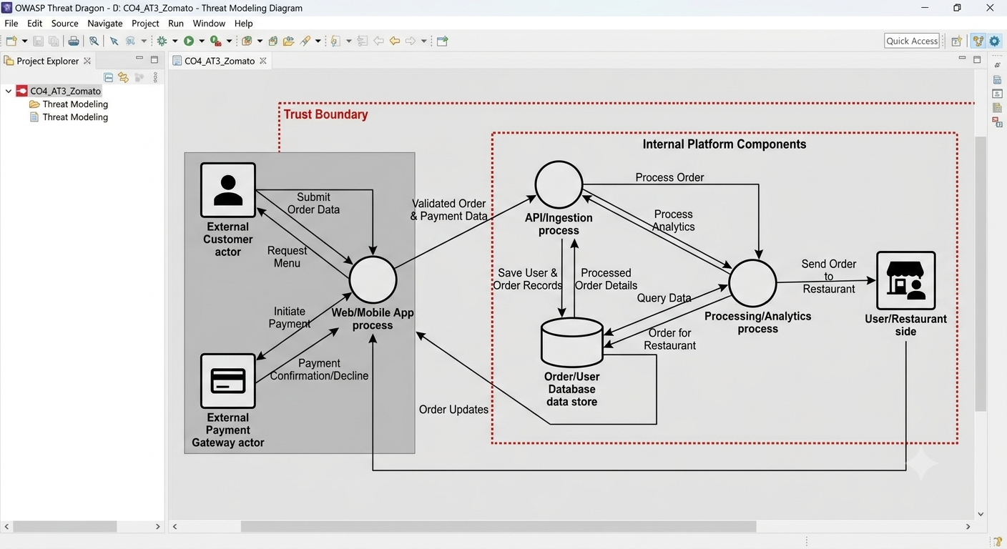

Final CO4 AT3 Solution Sections
Final Assembly
After completing the guided tool modules, combine the evidence into the final solution. The final answer must show technical reasoning and honest uncertainty, not only screenshots.

1. Platform Overview and Why It Was Selected
What to include: Identify the platform, its core users, its core function, and why it is a suitable reverse-engineering target.
Platform: Zomato — India's leading food delivery and restaurant discovery platform.
Core Users: Customers (ordering food), restaurant partners (listing menus, receiving orders), delivery partners (fulfilling deliveries), platform administrators.
Core Function: Connects customers with nearby restaurants for delivery and dining out. Handles order placement, payment, delivery tracking, and personalised recommendations.
Why suitable: Zomato is publicly accessible via browser, allowing direct DevTools inspection of API calls, endpoint names, response times, and payload sizes — all without internal access. Its multiple distinct data flows (search, menu, cart, auth, reviews) map clearly to cloud microservice patterns.

2. 5Vs Mapping (Inferred)
What to include: Map Volume, Velocity, Variety, Veracity and Value using the behavioural evidence gathered in Module 1.
Volume: HIGH — Millions of orders per day across hundreds of Indian cities; each order generates multiple events (search, menu view, cart, placement, status updates, delivery completion).
Velocity: HIGH — Search and autocomplete respond in 95-245 ms (directly observed). Order tracking requires continuous streaming. High-throughput ingestion layer inferred (Kafka-like).
Variety: MEDIUM-HIGH — Structured data (orders, profiles, restaurant metadata), semi-structured (JSON API responses, search queries), unstructured (food photos, review text), and sensor data (GPS pings from delivery partners).
Veracity: MEDIUM — Ratings are aggregated from user reviews (subject to fraud/bias). Location data has GPS noise. ETA is probabilistic, not guaranteed.
Value: HIGH — Analytics drives restaurant discovery, dynamic ETA, demand-based ranking, fraud detection, and targeted promotions — all core revenue drivers.

3. Inferred Data Pipeline and Architecture
What to include: Paste the final inferred draw.io architecture showing sources, ingestion, storage, processing, analytics/security and users.
Data Sources: Search activity, restaurant data (menu/photos/ratings), order/cart events, precise location (delivery partners), user activity (page views, session data).
Ingestion: API Gateway (all requests via api.zomato.com, confirmed via DevTools) + event/message ingestion layer (inferred: Kafka or similar) for order events and location pings.
Storage: User database (profiles, saved addresses, payment tokens), Order database (history, status), Event/log storage (clickstream, search history).
Processing: Real-time for search/ETA/order status; batch for ratings aggregation, demand forecasting, recommendation model training.
Analytics/Dashboard: Personalised home screen collections (observed in Chennai: 'South Indian special', 'Dine by the sea'), ETA per restaurant, demand analysis, business analytics for restaurant partners.
Users: Customers, restaurant partners, delivery partners, administrators.

4. Inferred Processing Approach
What to include: State the batch / streaming / hybrid decision from Module 3 with supporting evidence.
Decision: HYBRID (Streaming + Batch). Confidence: HIGH for streaming classification (directly observed); MEDIUM for batch classification (inferred).
Streaming (real-time needed): Restaurant search (95-245 ms response), autocomplete, order status updates, delivery partner location tracking, user session auth checks on every page.
Batch (periodic is fine): Overall restaurant ratings (aggregated from thousands of reviews), personalised recommendation models (trained offline on historical order data), demand forecasting reports, business analytics dashboards for restaurant partners.

5. Inferred Privacy and Security Risks
What to include: Summarize the threat model output from Module 4: risks identified and their likely or recommended mitigations.
Three principal risks from STRIDE analysis (Module 4 threat model):
1. Spoofing (Web/Mobile App Process): Attacker steals session token and impersonates user. Impact: unauthorised orders, exposure of saved addresses and payment tokens. Control observed: HTTPS (padlock visible), OTP login at signup. Confidence: HIGH.
2. Information Disclosure (Order/User Database): Misconfigured API or database leaks user PII (name, phone, address, order history). Impact: mass data breach. Recommended control: DB encryption at rest, strict API access controls, rate limiting — not externally visible. Confidence: MEDIUM.
3. Denial of Service (API/Ingestion Process): Public search API flooded with fake requests, degrading service for real users. Recommended control: API gateway rate limiting, bot detection. Not directly visible from outside. Confidence: MEDIUM.

6. Confidence and Evidence Summary
What to include: List each major inference made in this workbook alongside its confidence level (High / Medium / Guess) and the evidence it is based on.
Data Sources collected by Zomato: HIGH — directly observed (DevTools) + confirmed (privacy policy).
API Gateway ingestion: HIGH — every XHR request routes through centralised gateway (observable in DevTools).
Separate microservices for search / menu / reviews / cart: HIGH — distinct endpoints with different sizes and timings observed directly.
Event streaming layer (Kafka/similar): MEDIUM — inferred from sub-second streaming behaviour and food-tech industry norms; not directly observable.
Storage split into User DB / Order DB / Event store: MEDIUM — inferred from API structure and cloud architecture references; actual DB technology unknown.
Batch processing for recommendations: MEDIUM — home-screen collections appear pre-computed (no delay on load); could also be cached real-time.
Specific cloud provider: GUESS — not disclosed in DevTools or public sources found. StackShare shows partial data but Zomato's cloud mix is unconfirmed.

7. What Could Not Be Determined
What to include: State honestly which parts of the architecture, pipeline, or risk model could not be inferred from outside observation, and why.
Internal database technology: Specific DBs (PostgreSQL, Cassandra, DynamoDB) could not be determined — DevTools shows JSON responses but not the underlying store.
Event streaming technology: Whether Zomato uses Kafka, AWS Kinesis, Google Pub/Sub, or a proprietary system is not observable from the browser. This is an inference from industry norms and job posting analysis.
Cloud provider and region: No cloud provider was definitively identified from browser observation alone.
ML model architecture for recommendations: The ranking and personalisation algorithm (collaborative filtering, content-based, or hybrid) is entirely internal and cannot be inferred from observable API behaviour.
Exact fraud detection mechanisms: No CAPTCHA or device-fingerprinting signals were visible during normal browsing, so the specific controls in place are unknown from outside.

8. Business / Product Decisions the Analytics Likely Supports
What to include: State the measurable outcome the inferred analytics probably drives: faster ETA, higher conversion, personalized recommendations, fraud reduction, or similar.
The inferred analytics pipeline likely drives these measurable business outcomes:
1. Higher order conversion: Personalised home-screen collections ('South Indian special', 'Dine by the sea' in Chennai) reduce search friction and increase order placement likelihood.
2. Faster perceived ETA: Real-time delivery-partner location streaming and dynamic ETA recalculation directly reduce customer anxiety and improve satisfaction scores.
3. Restaurant partner retention: Demand analysis and business analytics give restaurant partners insight into peak hours, popular dishes, and customer demographics — increasing platform engagement.
4. Fraud reduction: Payment spoofing and order-tampering mitigations protect platform revenue and customer trust.
5. Dynamic pricing / surge management: High-velocity demand data enables delivery-fee adjustments and restaurant visibility tuning — a direct revenue optimisation lever.

Rubric
Criteria | Marks | Evaluation Focus | Evidence
Behavioural evidence quality | 6 | Observations are specific, sourced and go beyond guessing. | Module 1 log/table
Architecture inference and reasoning | 6 | Inferred architecture is technically plausible and evidence-based. | draw.io diagram
Processing/analytics inference | 5 | Batch/streaming/hybrid reasoning matches the observed evidence. | Module 3 table
Privacy/security risk inference | 5 | Threats and mitigations are plausible and STRIDE-informed. | Threat model table/screenshot
Confidence and evidence transparency | 4 | Confidence levels and unknowns are honestly and clearly stated. | Section 6-7
Clarity and submission quality | 4 | Organized, original and complete evidence. | GitHub/GCR

Total Marks: 30

Submission Checklist
Checklist Item | Status
Student details and selected platform are filled. | Done / Pending
Behavioural observation log is completed with at least 5 observations. | Done / Pending
Inferred architecture diagram is included with confidence levels noted. | Done / Pending
Processing/analytics inference table is completed. | Done / Pending
Threat model diagram/table is included. | Done / Pending
All 8 final solution sections are completed. | Done / Pending
"What could not be determined" section is honestly completed. | Done / Pending
DOCX/PDF and supporting files are uploaded to GitHub. | Done / Pending
GitHub repository link is submitted through Google Classroom. | Done / Pending

Official Reference Links
• AWS Architecture Center: https://aws.amazon.com/architecture/
• Azure Architecture Center: https://learn.microsoft.com/en-us/azure/architecture/
• Google Cloud Architecture Center: https://docs.cloud.google.com/architecture
• Apache Hadoop MapReduce Tutorial: https://hadoop.apache.org/docs/stable/hadoop-mapreduce-client/hadoop-mapreduce-client-core/MapReduceTutorial.html
• Apache Spark Structured Streaming: https://spark.apache.org/docs/latest/streaming/index.html
• Microsoft Threat Modeling Tool releases: https://learn.microsoft.com/en-us/azure/security/develop/threat-modeling-tool-releases
• OWASP Threat Dragon: https://owasp.org/www-project-threat-dragon/
• StackShare (public company tech-stack disclosures): https://stackshare.io/

